  - Project Change The World

Synonymous
A Warehouse for Positive Change
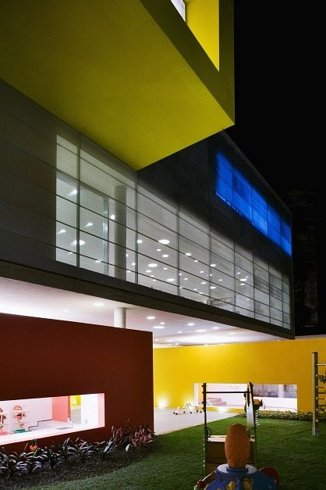
Phone: (704) 792-5003
E-Mail: projectchangeworld@gmail.com Web: http://projectchangetheworld.com/

A Place for Ideas and Inspiration
Synonymous will be an inspirational warehouse to empower you to make a difference using your gifts and passions! It will be a community space open to anyone interested in making the world a better place. The open-door policy will allow all individuals to stop by and be inspired to make a positive change. It will have a stage for music events, art stations, meeting space, office space, a store, and a cafe/coffee shop. In addition, there will be a hostel for those visiting Charlotte to stay at for affordable pricing. It will be a laid-back, colorful atmosphere with sofas, computers, inspirational artwork, a library, special events, workstations, TV's, quotes on the walls, and more! Project Change The World meetings will also be held here to collaborate, create, and ultimately change the world for the better! It will be a place to gather, bounce around ideas and promote a sense of community and unity between all people, regardless of our differences. We can hang out, talk, work, and throw events here! The possibilities are endless.
About Project Change The World

PCW began in early 2011 as a way to inspire others to give back to their community and make a difference in the world. The movement advocates the worldly needs that must be addressed on a regular basis and is a source of motivation for individuals that understand the importance of spreading peaceful acts of love. Anyone can partake in the kindness movement, depending on one’s interests and resources. The bottom line is that it is absolutely necessary to change the world into a better place through unity and consistency. We do this by regularly donating time, money, and spreading random acts of kindness. As the people of the world, we must ensure that this happens before it is too late. As such, “We must carry one another, rather than destroy each other.” For more information about the mega movement, please visit: http://projectchangetheworld.com/

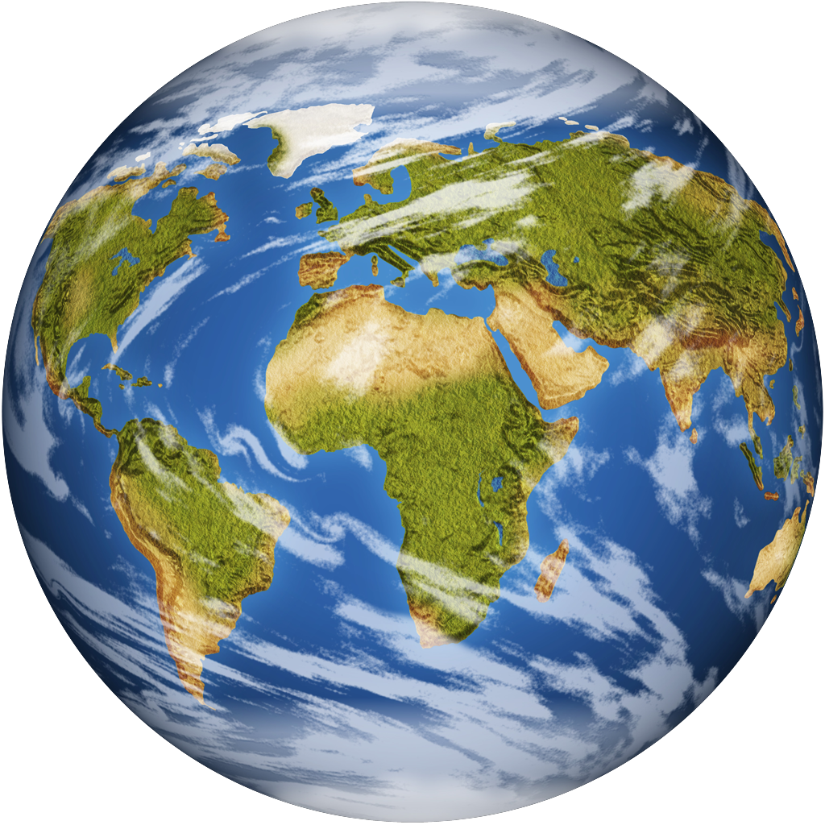

Why Synonymous?
“I don’t have time.” “I have work.” “I don’t think I’m the right person.” These are some of the common excuses I hear when I invite others to opportunities. I’m not saying that they’re lying but sometimes I wonder about our priorities. I’ve been guilty of doing the same, putting money first. Yes, we all have to pay the bills. But are we really just living to work? I don’t know about you but I don’t want to live to work. I want to live to love, to help, to learn, and to become the best version of myself that I can be. Anyway, if you have a roof over your head, a bed to sleep in, food on the table, and clothes on your body, you are richer than 75% of the world’s population. So what are we so worried about? We’ve gotten by just fine in the past, haven’t we? What about the 1 billion hungry? The 1 billion thirsty? What about the 1 billion that can’t read or write? Did you know that every 3 seconds, a child under the age of 5 dies from preventable causes, like diarrhea? Yet, we act like these lives don’t matter. We close our eyes and pretend like we can’t see. Perhaps, we tell ourselves that these people live on another planet and we can’t help. What does our voice matter anyway? We’re just one person. Right? Wrong. What if all of these people that said no before said yes? 100 people could say that their one dollar wouldn’t make a difference and we raise $0 or 100 people can donate $1 anyway and we have $100. In a third world country, that amount can save countless innocent lives. Change your attitude. Change your perspective. Change your mind. Change the world. It all starts with you.
However, I am aware that people will continue to live in their little boxes oblivious to the struggle right in their own neighborhoods. Nonetheless, Synonymous will give them, and maybe even you, a purpose to do something meaningful with the short time we’ve been given. The intent of this uplifting space is to reach people that normally play it safe or just don’t pay attention, as well as those who want to help but just don’t know how. Perhaps, you have a brilliant idea but you need help bringing it to life. Maybe, you even have an organization already but you want it to grow. I hope this place will open your eyes to the truth and move you to act. It should show you that, after all, you have more time, resources, and abilities than even you know about.
But you have to make time. You may have to cut out something less important in your life, like your 2-hour nightly TV date. You can wake up 30 minutes earlier or take just an extra 15 minutes right before you go to bed every night to do something purposeful. You have to volunteer, do your research and just get out in the community to learn the truth and gain the resources and knowledge you need to make an impact. Finally, you have to believe in yourself and believe that it is possible. Once you believe, learn, and create time, then you can begin to change the world.
Nonetheless, I understand that time is something we don’t have enough of. My hope is that by establishing set meeting times, you will reserve a space for something that should be a higher priority in your life. I hope that this space will create a positive, motivating environment for you and your dreams to make a difference. I hope that by creating a place with the unique purpose of inspiring others, you will walk in not sure if you’re in the right place and walk away knowing that you’ve found something worth your time. Changing the world is monumental and important. Come by and learn why that is and how that relates to you. I want to inspire you.

925 million hungry people in 2010
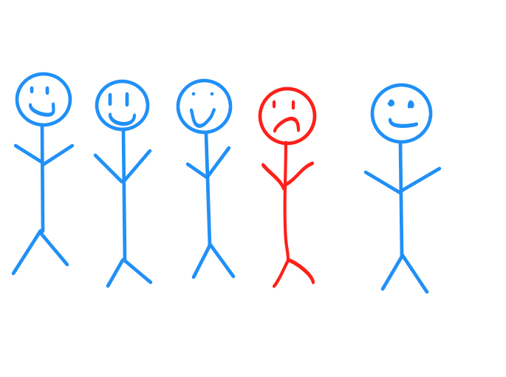
1 in 5 children in American live in poverty.
What will happen here?
The World Changers, the official members of Project Change The World, will hold our events in Synonymous. We will come together and share ideas about how we can make the world a better place. We will do this in a few ways:

- Inspirational Gatherings (1st Tuesday evening at 6:30 pm of each month)- once a month, we will ALL meet up and speak on topics that are important to us and relevant to making a difference. Think church meets school but the focus is on making the world a better place (plus it’s probably more exciting!). For example, we will learn about “being free” from all the burdens that hold us back, “going bigger”, the power of unity, why you really matter, fostering your passions, and so forth. We’ll conduct experiments, play games, do trivia, read inspirational true stories, make videos, watch movies, invite special guests, create art, hold fundraisers, and whatever else we want to do to make a difference! When it comes to doing good, there is no limit. These gatherings are open to the general public and each one will be unique.
- Power Board- PCW’s official board of influential members will meet here to plan our big events and focus on how we can take the movement to the next level to do even greater good. Nonprofits, activists, volunteers, and interested individuals of all types are invited to be a part of the decision makers of the mega movement!
- Action Teams- Outreach groups focused on a specific area. These small groups will meet on separate days/times to focus on an area of their choosing, such as animals, children, women’s rights, the environment, politics, faith, students, homelessness, the arts, and so forth. The World Changers in each group will decide when and where to meet and what to do. Some committees may even choose to team up for an event!
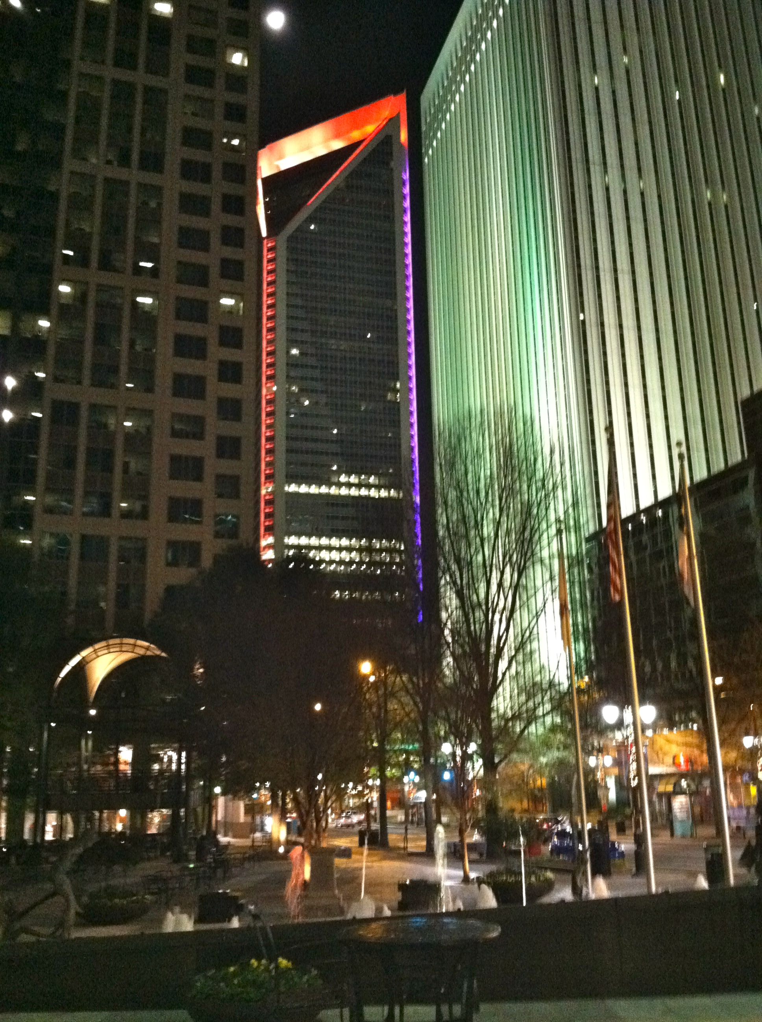
- Independence- The Inspiration Room will be available to the public to use and reservations may even be made! There will be workstations and resources available for use, such as books, notepads, computers, writing utensils, art stations, etc. Nonprofits and other organizations may book space to hold your own meetings in, as well.

Charlotte was ranked #2 in the nation in 2010 for its high percentage jump in family
homelessness, up 36%, according to a national survey from the U.S. Conference of Mayors.

Give a little and you can do a lot. Give a lot and you can change the world.

